**SYDE 101L Assignment 5**

**2022-12-04**

Figure 1. The figure illustrated a linear regression after logarithm transformation. The voltage decrease as the frequency increase.

Figure 2. Predicted the trend of the voltage based on the linear regression formula. The higher the frequency the lower the voltage.

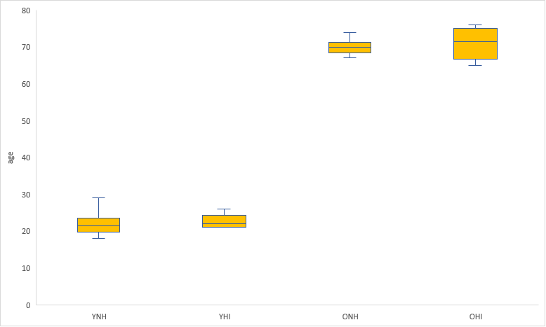

Figure 3. This box plot contains the age distribution of the people in different age groups and hearing ability.

Figure 4. This bar graph demonstrates the reaction time under simulated conditions depending on ages and hearing ability.

|  |  |
| --- | --- |
| Ages groups and hearing ability | Reaction time standard error (ms) |
| YNH_RT (Young normal heading reaction time) | |  | | --- | | 85.84715 | |
| YHI_RT (Young hearing-impaired reaction time) | 135.9443 |
| ONH_RT (Old normal heading reaction time) | 161.5599 |
| OHI_RT (old hearing-impaired reaction time) | |  | | --- | | 235.6514 | |

The colour used in Figures 3 and 4 is yellow. Based on the parula scale, yellow represents the maximum rating. Reaction time for all the age groups is important therefore the maximum scale will remind the audience to pay attention to the average value for each age group.